Aarian Moogat

010565958

Math 170

**HIV Modeling**

The biological application chosen in this report was modeling HIV, specifically the spread of the virus in the body. There is a direct correlation between the cells that have been infected by the virus and HIV, the virus that causes AIDS. The studies show that while the disease generally stretches itself out over a 10 year time scale, there are actually several ways to study and map out the disease on a monthly, weekly and even daily basis. HIV mainly targets a set of white blood cells known as CD4+ T cells. Once this count which is normally 1000 reaches 200, there is an immunodeficiency, the effects of which are categorized as AIDS.

Modeling in this situation has multifarious beneficial effects. It was through modeling that mathematicians figure out that based on the rate of development in the disease (sometimes mutating multiple times a day), a single medicine or treatment was deemed ineffective. A multi pronged approach is often time used to prolong the lives of those with AIDS, with mathematical modeling being used to look at the T cell count and predict how best to hinder the decline of the T cell count. One huge problem with the disease is that there is an asymptomatic (no symptoms) period in which people do not exhibit symptoms of the disease, and yet have infected cells and a low amount of T cells. The level that the virus falls to after the primary infection is known at the setpoint, and the virus levels will stay around this setpoint during this asymptomatic period of time, while their T cell count drops. Modeling can help us figure out this setpoint, as well as how stable or unstable it is based on the strength of the infection (a function or equation).

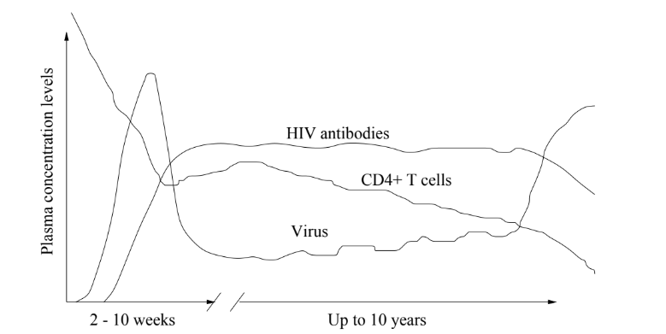

T(t): this represents the population of uninfected CD4+ T Cells at time t.

I(t): this is representative of the population of infected CD4+ T Cells at time t.

V(t): this is representative of the population of virions, or infectious particles at time t.

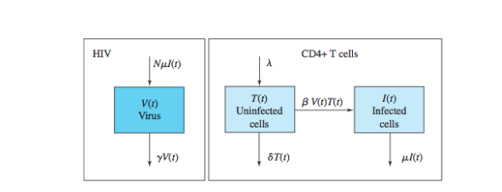

λ : lambda is recorded in cells/day and corresponds to the production rate of the input source of uninfected cells per day

δ : delta is representative of the normal loss rate constant of uninfected cells per day, making 1/δ the average lifespan of an uninfected cell in days

μ : mu is representative of the loss rate constant of infected cells per day, making 1/μ the average lifespan of an infected cell

ϓ : upsilon is representative of the loss rate constant of the free virus per day, making 1/ϓ the lifespan of a virion

β : Beta is representative of the infection rate constant of uninfected cells per day and is directly proportional to both V(t) and T(t)

**Model Analysis:**

Using these values and compartmental analysis, I derived the following formulas for the rates of change in all compartments (T I, and V).

**Ṫ = λ - δT - βVT**

**İ = βVT - μI**

**̇̇V̇ = μI - ϓV**

As is implied above, there are many variables in modeling HIV-1 and its spread. Technically speaking, there are two more differential equations that are used in the model: one for the recombinant, or second virus, and one for the double-infected cells. However, for the sake of this analysis, the equations used will model just the HIV-1 virus.

There are methods to solve these differential equations in a number of ways, or at least gather a breadth of information from them even if there is no exact numerical solution. For the system, I will make a couple of fair assumptions, namely that Beta = 0 and that T(0) = T0, V(0)=V0, I(0) = I0. This means that the infection rate constant is no longer going up, and that the implemented treatment is fighting off the infection. The first equation, (Ṫ = λ - δT - βVT) would be Ṫ + δT = λ after some algebra. I will use solution methods now to solve this differential equation for T

**Integrating Factor: eλ → Teδt = ∫ λeδt dt + C1**

**→ [Teδt]= (λ/δ)eδt dt + C1 → T(0) = T0 → C1= T0 - (λ/δ)**

**→ T = (λ/δ) + (T0- (λ/δ))e-δt**

This now gives us the concentration T for any time t as long as the initial concentration of T and the parameters discussed are given, some of which have known ranges that are substitutable. The next equation, İ = βVT - μI can also be solved using a solution method. Again, given that B=0 and that I(0) = I0:

**dI/dt = -μI → (1/I)dI = -u dt → lnI = -μt + C2**

**→ I(0) = I0  → lnI0 = C2 → I = e-μt + ln(Io)**

**→ I = I0 e-μt**

This gives us the concentration for I so long as I0 is known and there are constant values for the parameters. The last equation, ̇̇V̇ = μI - ϓV can also be solved using solution methods:

**̇̇V̇ = μI - ϓV → V̇ - ϓV = μI → I = I0 e-μt → V̇ + ϓV = μ( I0 e-μt)**

**→ Integrating Factor: eϓt → [Veϓt] = ∫[eϓtμ( I0 e-μt)]dt + C3**

**→ [Veϓt] = μ I0 e(ϓ-μ)t / (ϓ-μ) + C3 → V(0) = V0 → C3= V0 - μ I0 / (ϓ-μ)**

**→ V= μ I0 (e-μt) / (ϓ-μ) + V0e-ϓt - (μ I0 e-ϒt) / (ϓ-μ)**

Looking at these equations there is interpretable information. To check the end behavior, plug in t → ∞ into these equations (Remember that B=0, so the virus should not be spreading). Upon plugging it into the V(t) equation, the result is a 0 for all 3 terms, as they all have some -t term in the exponent. On plugging in t → ∞ to I(t), the result is a 0, and if it is t → ∞ to T, which is the population of the uninfected T cell count, the result is (λ/δ). This all checks out logically, as the T term is the only one which should not be 0 given that B = 0 and the infection is not spreading.

Now as for the stability of most equations, stability in this case will revolve around the parameters and initial conditions. To calculate the stability at the fixed points, first I had to find what the fixed points are for this system of equations. In order to do this, I went back to the differential equations and set the differential term = 0. In other words, I was checking for when the change in the population of concentration of either the uninfected, infected, or viral cells is 0. (**Italicized = Fixed Point**)

**Ṫ = λ - δT - βVT → 0 = λ - δT - βVT**

**→ δT + βVT = λ → T( δ + βV) = λ → *T* = λ / ( δ + βV)**

**İ = βVT - μI → 0 = βVT - μI**

**→ *I* = (BVT)/μ**

**V̇ = μI - ϓV → 0 = μI - ϓV**

**→ *V* = (μI) / ϓ**

Now to calculate the Jacobian matrix of this system of equations. In order to do this, get the partial derivative of each compartment for each equation and set it in a matrix. I put the equations into MATLAB for a faster process, like so:

**J(T,I,V) = {{-δ - βV, 0, - βT},{βV, - μ, βT},{0, μ, -ϓ}}** → already partially derived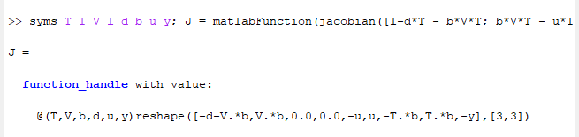

*Note that in the above picture, lambda (λ) is l, Mu (μ) is u, ϓ is Y, δ is d, and β is b.

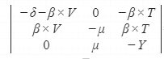 where Y is ϓ.

Inputting the previously italicized Fixed Points **T** = λ / ( δ + βV) and **V** = (μI) / ϓ will get the Jacobian in terms of I, V, and the parameters, and therefore determine stability of the fixed point around these. There are no I terms in the Jacobian Matrix. Plugging in **T =** λ / ( δ + βV) and **V** = (μI) / ϓ as the other fixed point into the Jacobian matrix gives us the stability based on an analysis of certain respective eigenvalues.

Next is to determine the stability of the fixed point according to the Theorem: An equilibrium is asymptotically stable if all eigenvalues have negative real parts; it is unstable if at least one eigenvalue has a positive real part.

**Example:**

When looking at some of the biologically natural values, the average lifespan of a CD4+T cell is two years, making δ = 0.001369 or ~ 0.001. Being the death rate of the virus, ϓ is on average = 2.5 cells per day. Μu is typically ~0.33 cells per day, while Beta is anywhere from 0.00027 to 0.00065 (using 0.0005 here). λ is the production rate of the host cell, resulting in 2 cells/mm3 per day. Upon inputting this data into MATLAB, along with initial conditions T(0)=200 (indicating # of uninfected host cells at time 0) and V(0) = 10-6 (indicating the number of virus cells that entered the body at time 0), it is seen that the population of the virus increased rapidly within the first week, then stabilized out within the first month. The CD4+ T Cells were heavily tolled, dropping straight down from 200 to nearly 0.1 before stabilizing out at about 6.

The system, upon using the values in MATLAB above negative eigenvalues in the real portion. This means that they remained locally stable. On a larger scale, the values quickly converge without blowing up to infinity, making this a stable system.

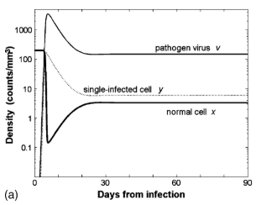

**Interpretation**

These equations have a convergent nature, and this indicates a few things. For one, it means that the initial quantity of viral cells may quickly snowball into this end behavior, and so any amount of virions can potentially cause AIDS. The studies that go into prevention of this disease logically try to use anti-viral medication. Few things spread quite as exponentially as a virus, and so some of these medications include another virus (obviously this one is non-harmful or significantly less so) in order to combat the virus. The analysis also gave us a way to calculate the concentration of either the virus, the infected, or uninfected cells in terms of the initial values and parameters. I was also able to figure out the local stability and long term stability of the infection given certain values that is found in nature.

**References**

Perelson, Alan S., and Patrick W. Nelson. “Mathematical Analysis of HIV-1 Dynamics in Vivo.”

*SIAM Review*, vol. 41, no. 1, 1999, pp. 3–44., doi:10.1137/s0036144598335107.

Revilla, Tomas, and Ramos, Gisela. “Fighting a virus with a virus: a dynamic model for HIV-1

therapy.” Biodiversity Data Journal 4: e7720. Oct. 2003, doi:10.3897/bdj.4.e7720.figure2f.